MCB Performance Core procedures and return / refund information

1 - What is a "good" core? A good core is simply one that can be re-conditioned to MCB standards.
2 - The core returned MUST be the same exact make, model, style and CASTING NUMBER as the one you purchased!
2 - Crankshafts must be complete and ALL counterweights must not have any severe damage. We prefer the connecting rods also be useable but depending on the application we use new connecting rods anyway so that may not automatically disqualify the crankshaft. If the crankshaft is broken at a cross pin the crank may still be a good core because all pins are replaced when rebuilt anyway. The center gears are also typically replaced with new when available so that also does not always denote a bad core. Lastly, even with some damage to re-used components we will credit you the % of good parts. For instance if you have one counterweight heavily damaged of the 4 in a twin 2-stroke you will likely still receive 75% of your core refund, etc.
3 - Cylinder cores must be the SAME CASTING #. Cylinders must NOT be ported (we can simply replate your cylinders if this is the case). Cylinders must not be "sleeved" where they were not originally. Cylinders cannot be AFTERMARKET brands. Also core refunds may be reduced for the following: Stripped threads, broken skirts, and sealing surface damage and dings. We expect the bores to have damage and scoring (preferably less than 50% of total area) and that is perfectly acceptable however if there are large cracks or DEEP transfer port cracks (common in the 800 Etecs) that cannot be accessed for welding, or completely missing skirts (common to 800 Polaris) those cores are often not useable. Cylinders that have re-plated poorly or plated more that 3-4 times will generally fail in the process so keep that in mind as well.
4 - PACKING your core for return is VERY important. This is often where additional damage occurs and can lead to losing your refund. A crankshaft is extremely hard to damage but a cylinder is EASY to damage. You MUST protect the cylinders' external surfaces (head surface, base, skirts, etc.) when shipping the core back. We recommend wrapping the cylinder(s) in cardboard first and then putting the cylinder in a box thereby protecting it from droppage and other cores banging together as it travels.
5 - You MUST include your purchase information with the cores you are returning. We normally include TWO copies of you invoice when we send you your new parts with a note saying to send the 2nd copy back with your cores. If you do not have a copy of your invoice, then please look up your sales order # and write that number on the outside of the box. Also, if you are sending your cores from a location that has their business name on the label please have then ADD YOUR NAME to the label if possible.
6 - MCB receives large amounts of cores on a daily basis, we allow the customer 30 days to return the cores and we can also take up to 30 days to process the core return. Please be patient and if you want to check its arrival at MCB, DO NOT CALL but rather check YOUR tracking # to verify its delivery. From that date you can expect roughly 20 business days before you see the credit on your account.
7 - MCB will not be responsible for any loss of core funds if ANY of the above guidelines are not followed.

How to wrap cylinders BEFORE boxing them - see pic.
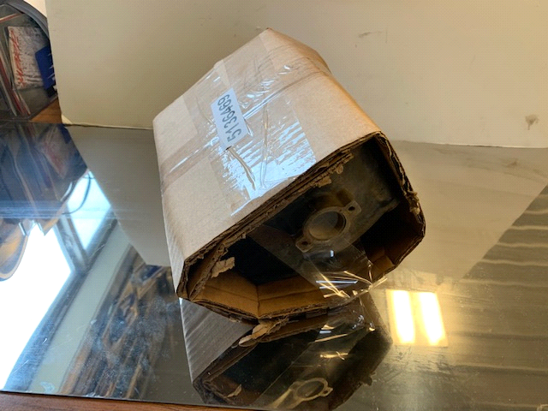

Thanks for all your business - MCB Performance

